PROJECT REPORT
Name:S.Rithanya
Registration no :25BOE10067
Title:Aqua pH monitoring system
Introduction
This project implements a Python-based simulation of an aquarium pH monitoring system. The system generates random pH values within typical aquarium ranges, evaluates their safety for aquatic life, and provides maintenance recommendations. It demonstrates fundamental programming concepts applied to real-world environmental monitoring.
Objectives
- Simulate realistic aquarium pH monitoring
- Implement conditional logic for safety evaluation
- Generate actionable recommendations based on pH levels
- Create a user-friendly console interface
- Model environmental monitoring principles
System Requirements
Safe pH Range
- Optimal Range: 6.8 - 8.0 (Safe for most freshwater aquatic species)
- Unsafe (Acidic): < 6.8
- Unsafe( Alkaline): > 8.0
Algorithm
1. Generate random pH: uniform(6.0, 8.5), rounded to 1 decimal
2. Evaluate status:
IF 6.8 ≤ pH ≤ 8.0 → "SAFE"
ELSE → "UNSAFE"
3. Display formatted output
4. Provide recommendations based on status and pH value
Code
import random
#ph generation
ph = round(random.uniform(6.0, 8.5), 1)
#safety evaluation
if 6.8 <= ph <= 8.0:
status = "SAFE"
else:
status = " UNSAFE"
#output
print("AQUARIUM pH MONITOR")
print("*" * 25)
print(f"pH: {ph}")
print(f"Status: {status}")

if status == " UNSAFE":
if ph < 6.8:
print(" RECOMMENDATION: Add pH UP chemicals")
else:
print(" RECOMMENDATION: Add pH DOWN chemicals or change water")
else:
print(" RECOMMENDATION: Maintain current conditions")

print("*" * 25)

Sample outputs
1.
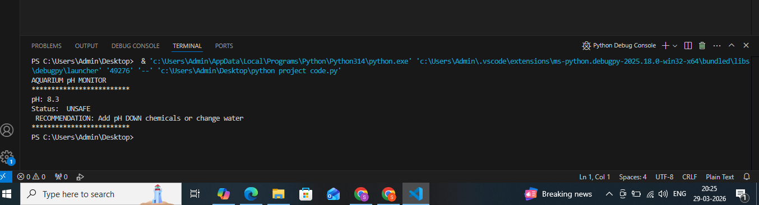
2. 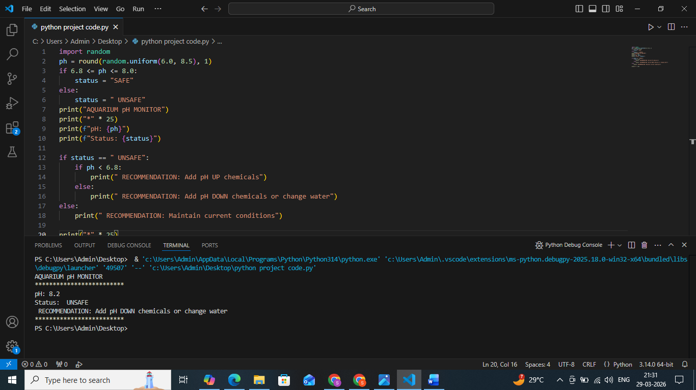

Programming concepts demonstrated
- Random number generation
- Conditional statements
- Boolean logic
- Numeric rounding
- String formatting
Limitations
- Single parameter monitoring (pH only)
- No persistent data storage
- Console-based interface only
- Static safe range (not species-specific)
Future Enhancements
- Multi-parameter monitoring (temperature, ammonia, nitrates)
- Data logging to CSV files
- Graphical user interface (Tkinter/PyQt)
- Species-specific pH ranges
- Trend analysis and alerts
- Web-based dashboard
Conclusion
An Aquarium pH monitoring system successfully demonstrates how basic python programming can model real world environmental monitoring applications.The implementation robust ,user friendlyand provides accurate recommendations based on real life science applications.

